**NATIONAL UNIVERSITY OF COMPUTER AND EMERGING SCIENCES**

**PROGRAM: SOFTWARE ENGINEERING**

|  |
| --- |
|  |
|  |  |



***OPERATING SYSTEMS LAB***

**LAB TASK- 01**

**SUBMITTED BY:**

**Name: Ahmed Ali**

**Roll No: 22P-9318**

**Section: BS(SE)-5B**

**INSTRUCTOR NAME: Sir Saad Ahmed**

**A DEPARTMENT OF COMPUTER SCIENCE**

**LINUX (UBUNTU) INSTALLATION MANUAL Along-side With Windows 10:**

1. First of all You need to search for UBUNTU in your web browser and **click on Download Ubuntu Desktop**:

[*https://ubuntu.com/download/desktop*](https://ubuntu.com/download/desktop)

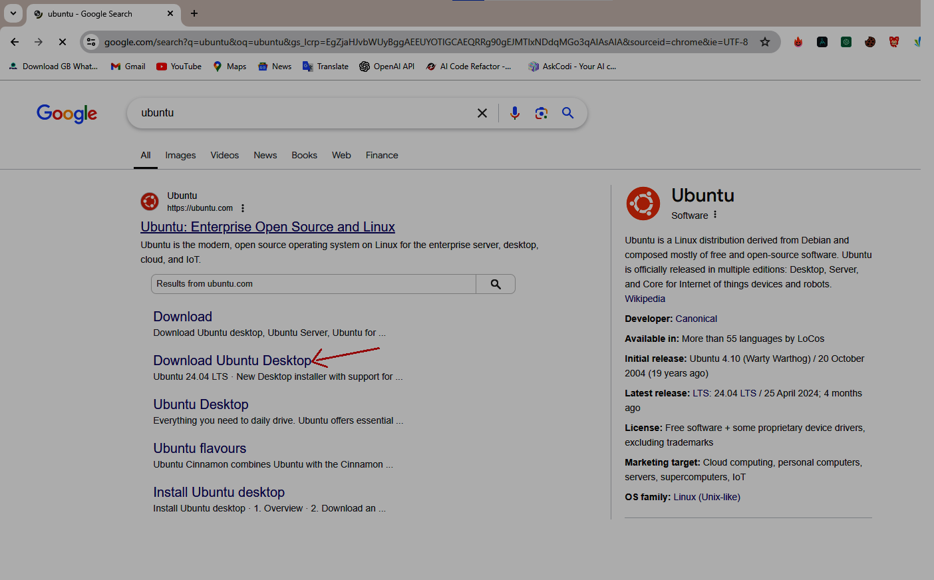DOWNLOAD

1. Now a new page appears in front of you, You need to click on **Download 24.04 LTS as highlighted in the image below**:

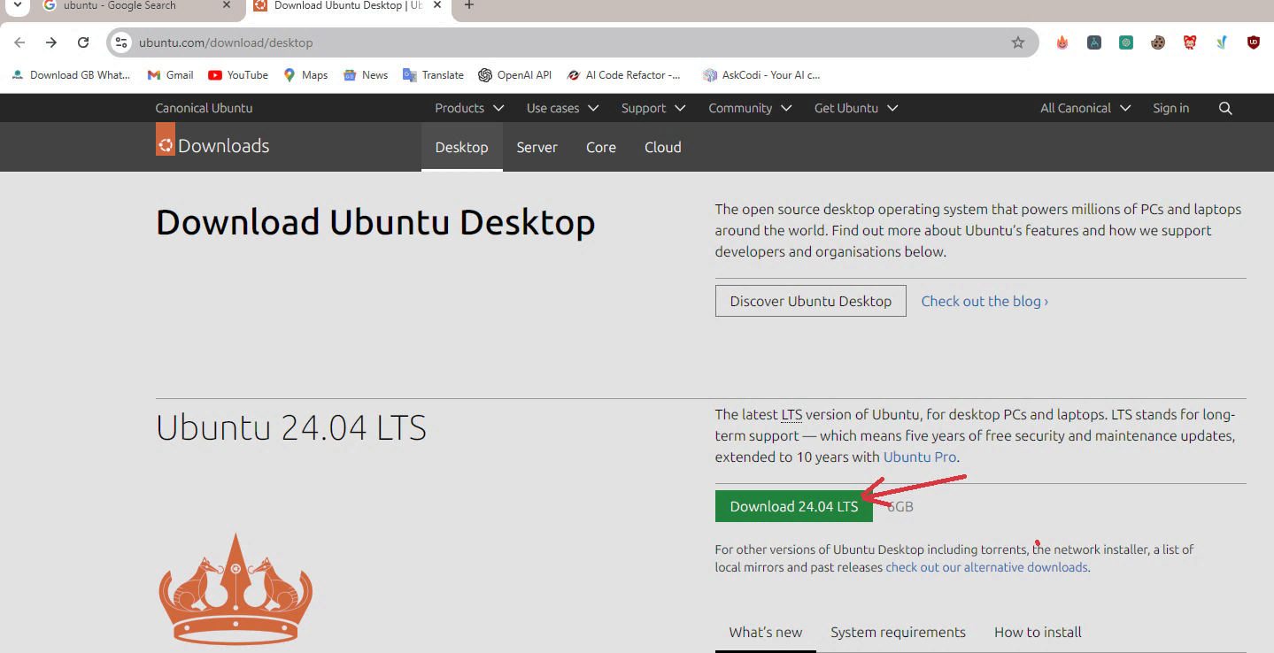

1. 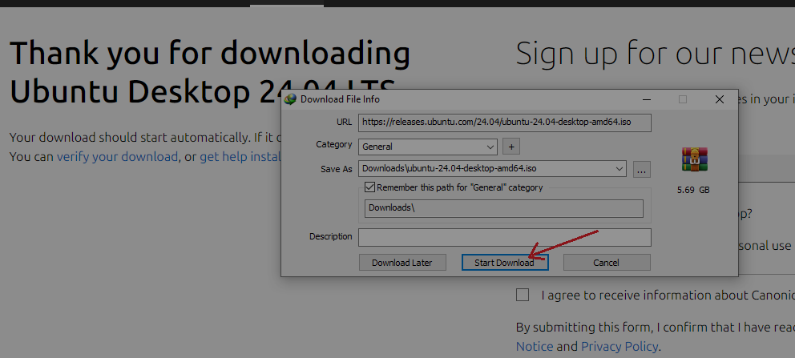**Click on Start Download** option as Shown in below Image:

1. While it is downloading **You have to search for Rufus**, and download it: *https://rufus.ie/en/*

(*Rufus helps you to make a USB drive or CD drive bootable)*

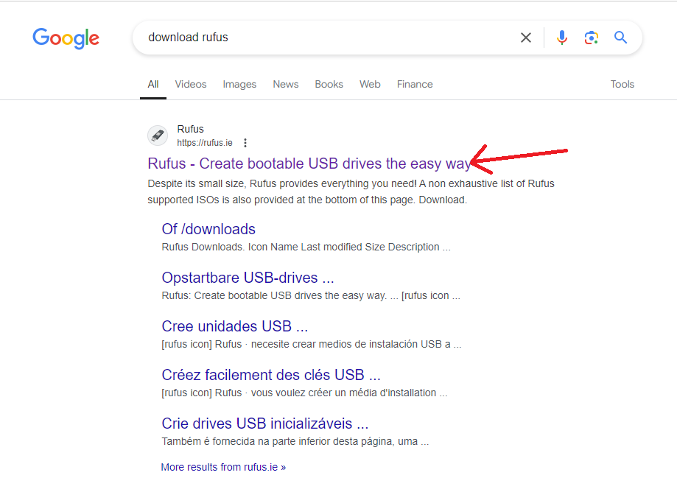

1. A new Window appears scroll down and **you will find 4 versions of Rufus to download Select the First one:**

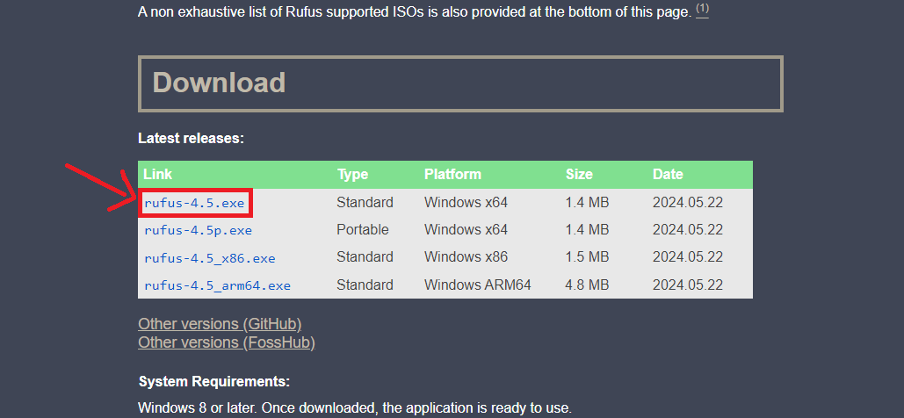

1. 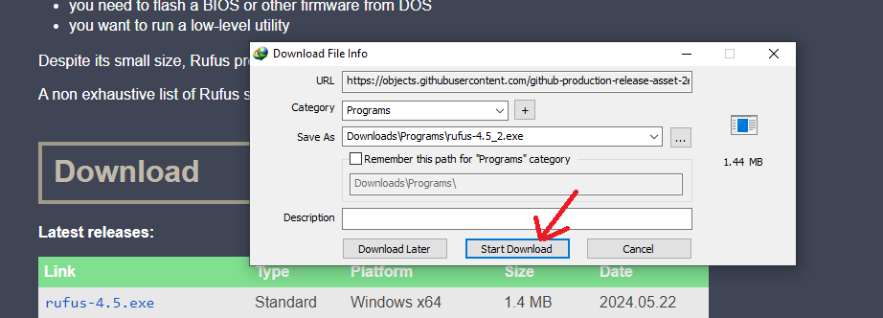A window will appear ***if you are using Internet Download Manager you have to Click on Start Download option*** *otherwise it will directly start the download*:
2. Now go to the start menu and ***search for disk part an option will appear with the name of Select and format hard disk partitions click on it:***

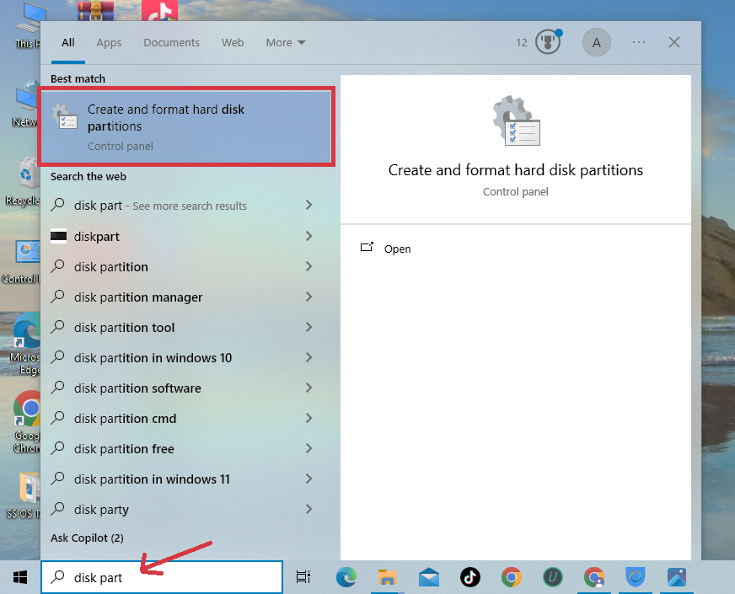

1. A ***Disk Management Window***will appear in front of you ***Right Click on Disk 0 as Shown in the image below*** Select the **Properties** option and **click on it**.

🡪 A new Window will appear showing all the properties of the disk ***Click on the Volumes Tab*** *as shown in Image* Below, now you are seeing many properties ***but here you have to remember the partition scheme; it can be either MBR or GUID Partition Table (GPT)***

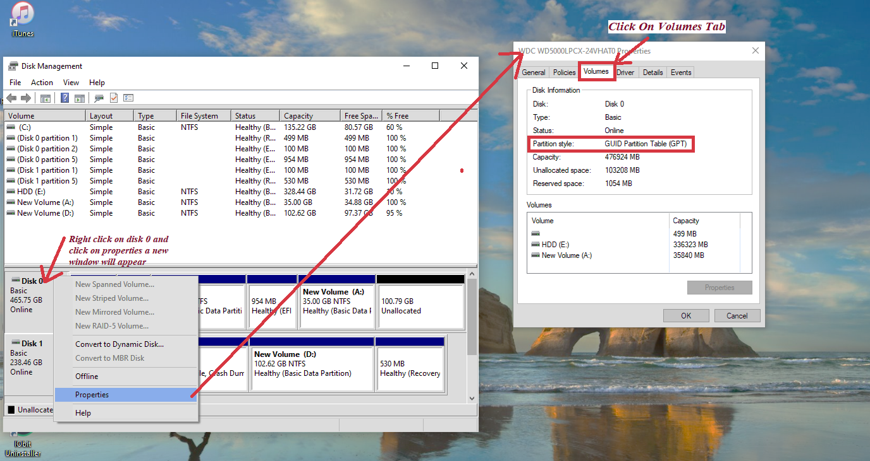🡪 ***In my Case it is GPT.***

1. 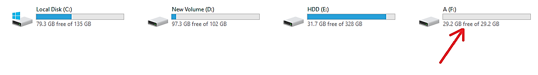***Now Insert a USB drive, We will make it bootable:***
2. *Now* ***Double Click On the Rufus Icon:***

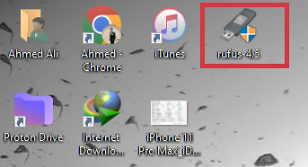

1. In front of you ***A new window will appear Of Rufus*** ***you will see in the device The inserted USB drive will be selected automatically if not select the USB Drive you want to make bootable.***

* In the Boot Selection Select Disk or ISO image, Now **as shown in the image below click on the Select option** A new Window will appear *Select the Downloaded UBUNTU ISO image File and Click on* **Open:**

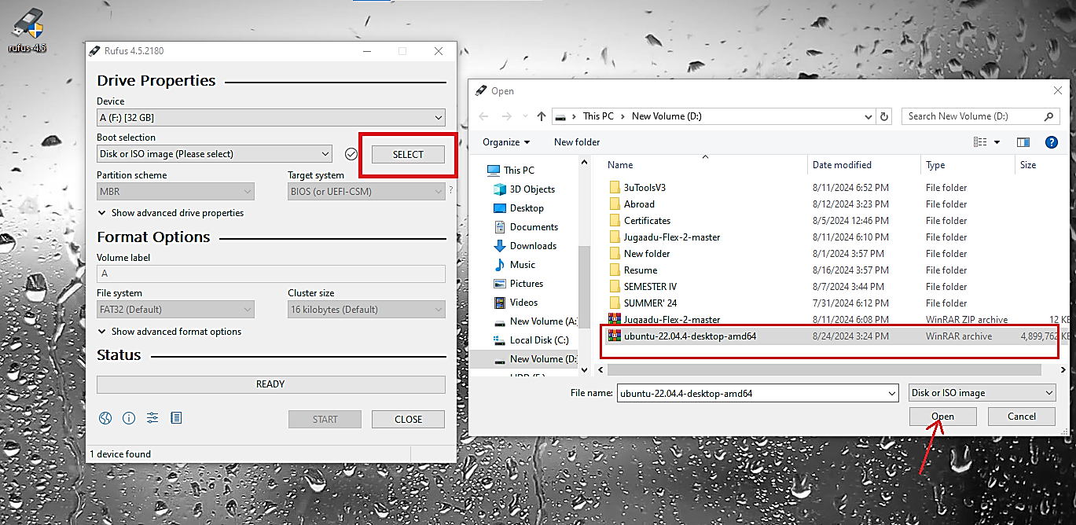

1. Now **In the Partition Scheme** **I have asked you to remember the partition Style in (Point 8)** *Select The option as per your Partition Style*, ***In my case its GPT so I have to select GPT in Partition Scheme and click on start:***

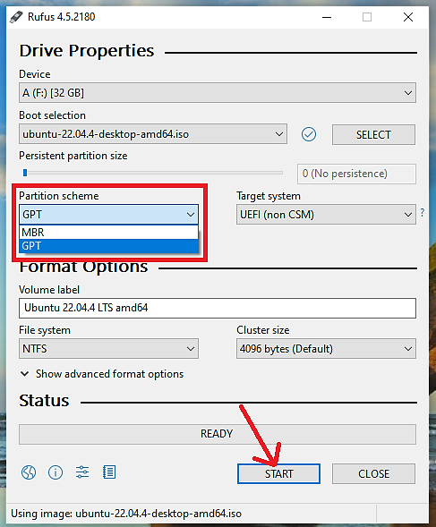

1. It will take some Time to make your USB Drive Bootable ***Once its completed, Restart your PC and go to the boot menu, for going in boot menu while your PC is starting press F9 key (for HP devices) The boot menu will appear:***

* ***­In the Boot Menu Select Your USB Drive And press Enter as Shown in below Image:***

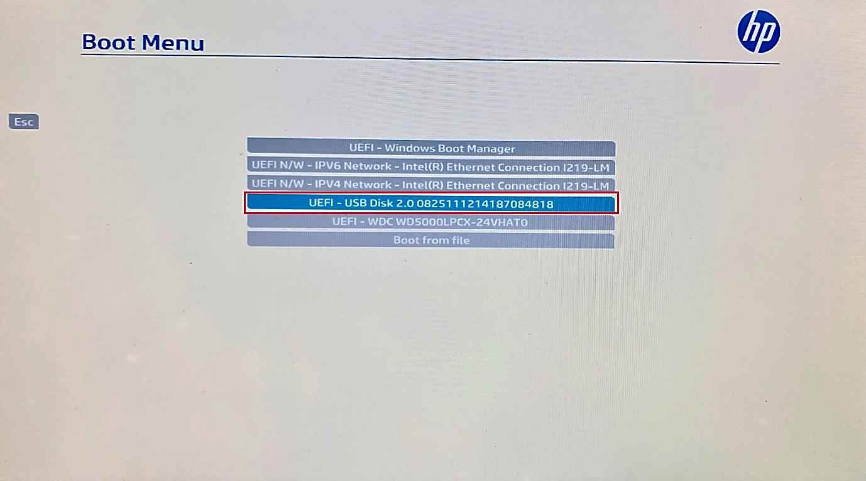

1. Once the USB Drive boot-up a new grub screen should appear on your monitor. ***From the menu select Install Ubuntu and hit Enter to continue:***

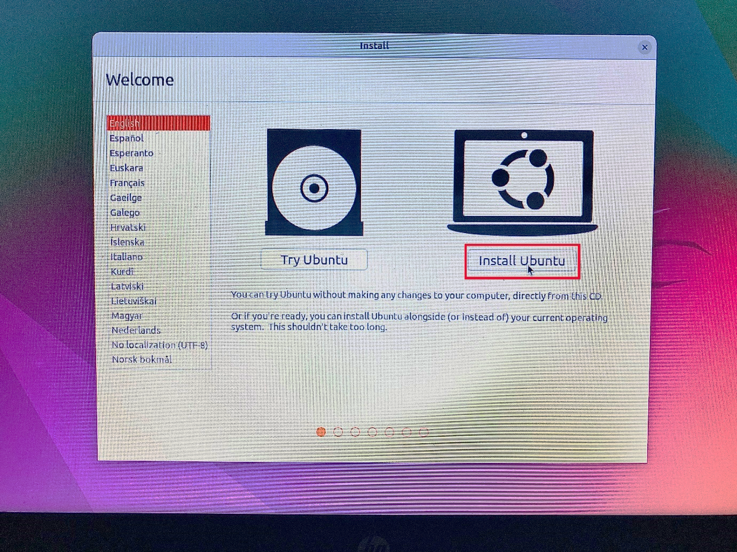

1. ***Choose the language you wish to perform the installation and click on the Continue button to proceed further:***

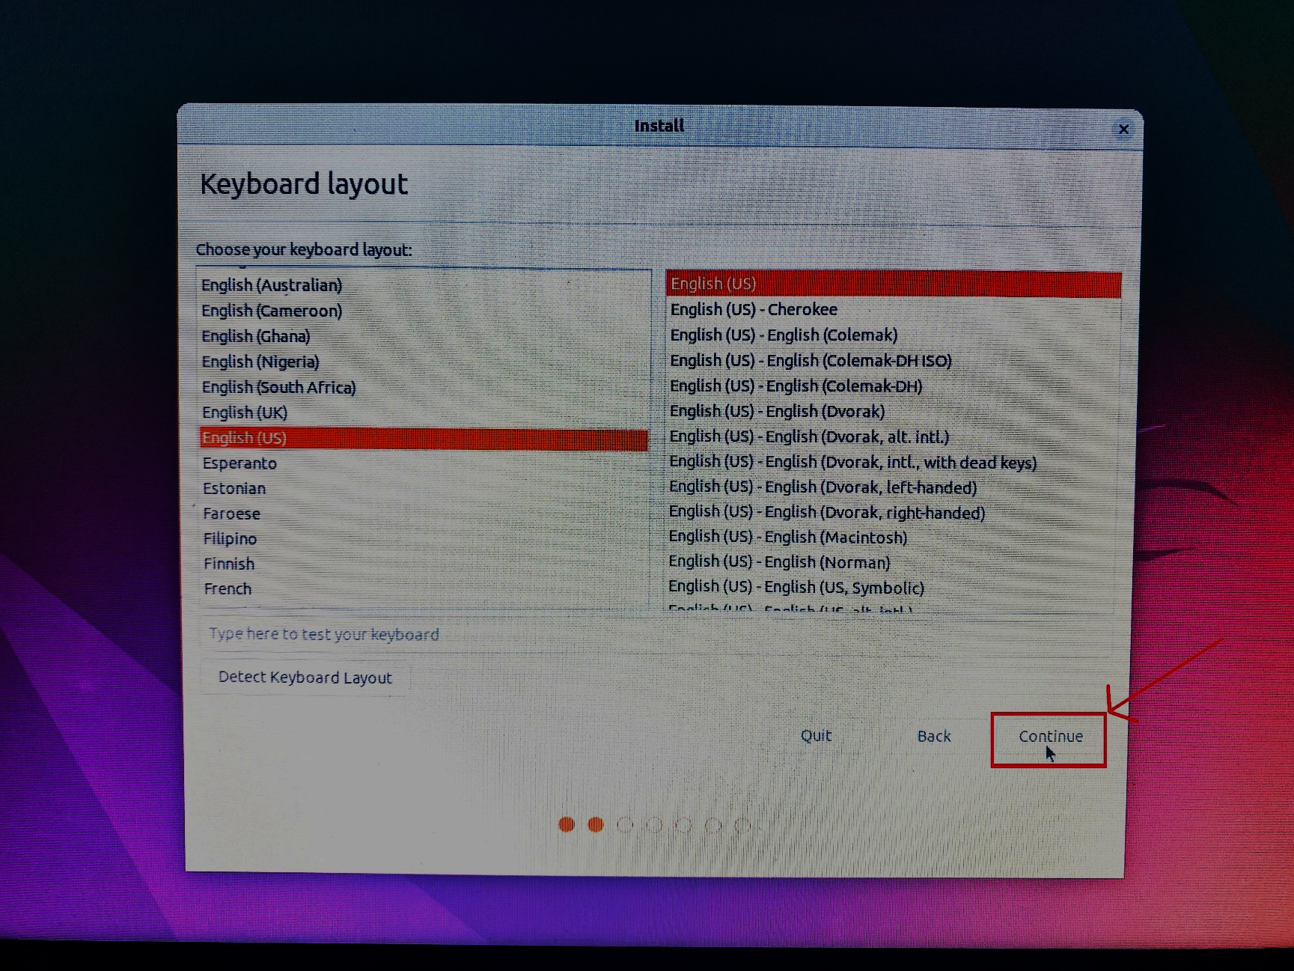

1. 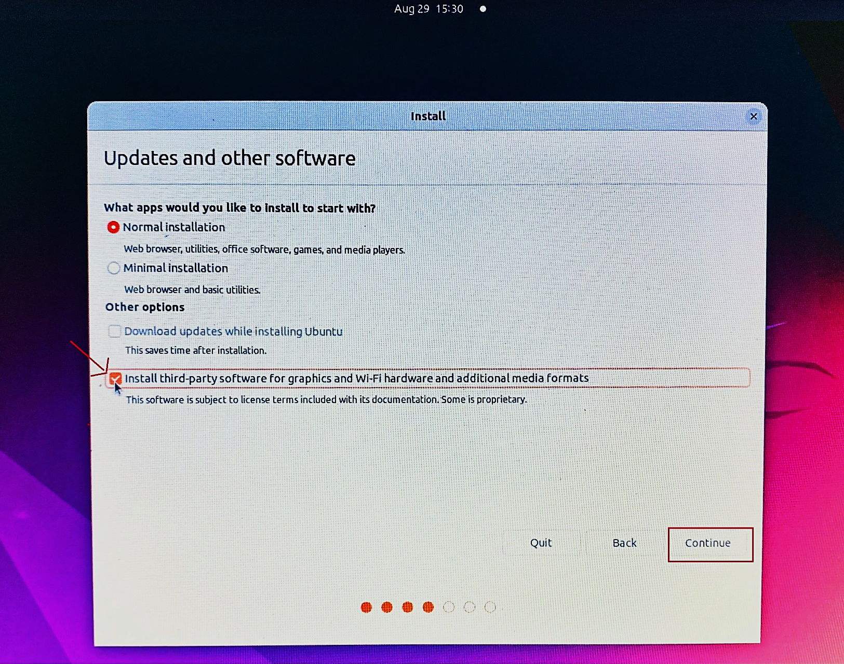Next, ***choose the first option “Normal Installation” and click on Install third-party software for graphics and Wi-Fi hardware and additional media formats,*** next hit on the Continue button again.

1. Now it’s time to select an Installation Type. ***You can choose to Install Ubuntu alongside Windows Boot Manager***, (*an option that will automatically take care of all the partition steps)*. **Use this option if you don’t require a personalized partition scheme.**

* *In case you want a custom partition layout, check the* ***something else option and hit on the Continue button*** *to proceed further.*
* ***The option Erase disk and install Ubuntu should be avoided on dual-boot because is potentially dangerous and will wipe out your disk.***

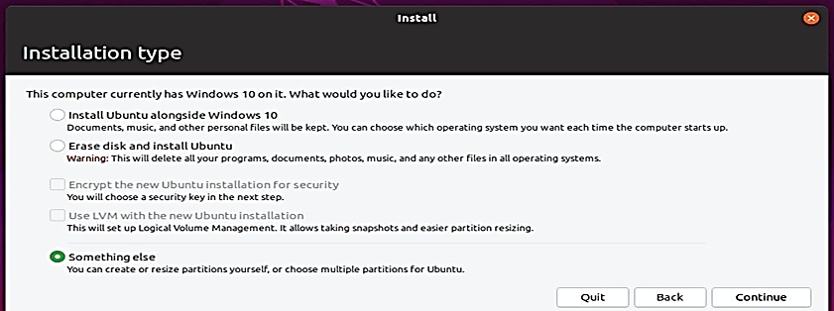

1. Next It’s time to create partition, ***It’s important that you must have at least 20-GB Free space to install UBUNTU*, In my case I have 145-GB Free space.**

* **If you haven’t sufficient space; then you have 2 options:**

1. *Delete a drive other than the drive in which Windows is Installed.*
2. *Before booting UBUNTU go to Disk Management and Shrink At least 20 GB of Volume from it.*

* ***So I Right Click on free space and click on the add option***
* 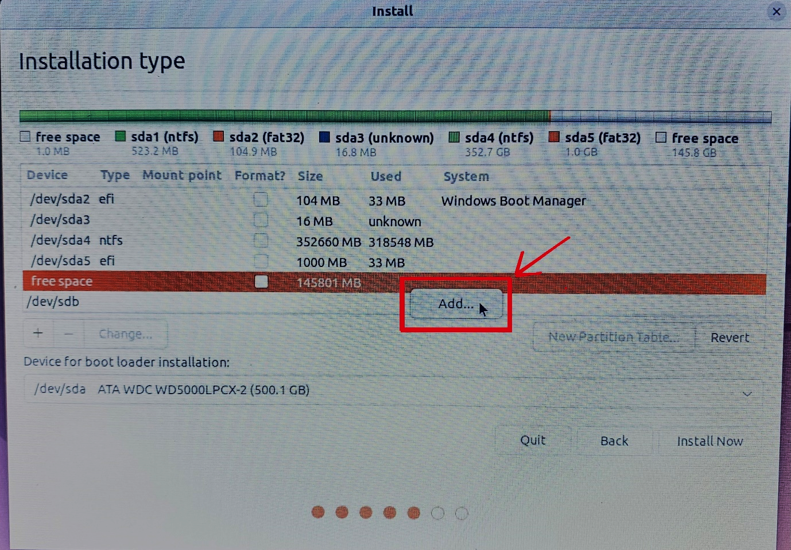

1. Next in the Size box type 20480(in MBs) which is equal to 20 GBs, ***In my case I have more space so I give 36864(in MBs) which is equal to 36 GBs.***  
   Type for the new partition = Primary

Location for the new partition = Beginning of this space

Use as = EXT4 journaling file system

Mount point = /

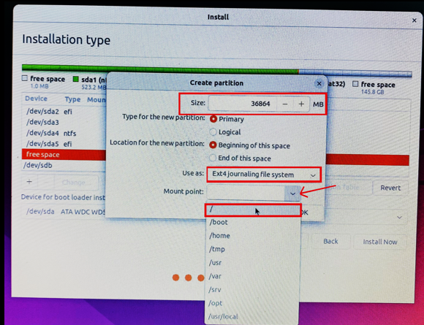

1. ***Click On OK Button***

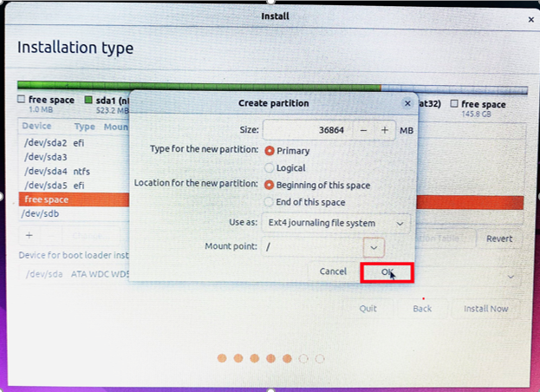

1. 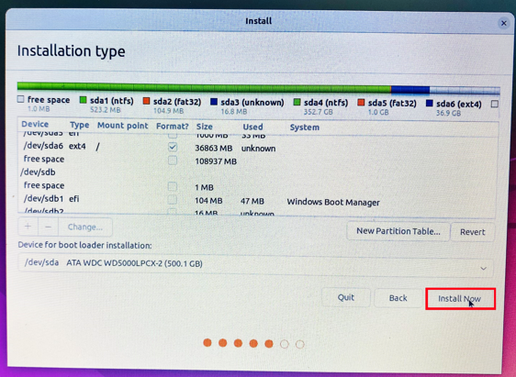When finished, ***hit the Install Now button*** in order to apply changes to disk and start the installation process.

1. Next, a new pop-up window will ask you if you agree with committing changes to disk. ***Hit Continue to write changes to disk and the installation process will now start.***

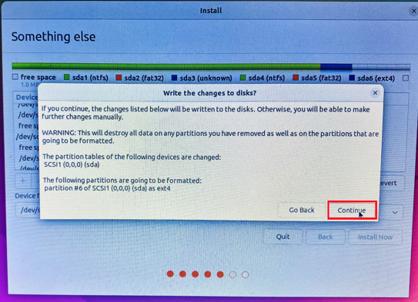

1. ***SELECT YOUR REGION:***

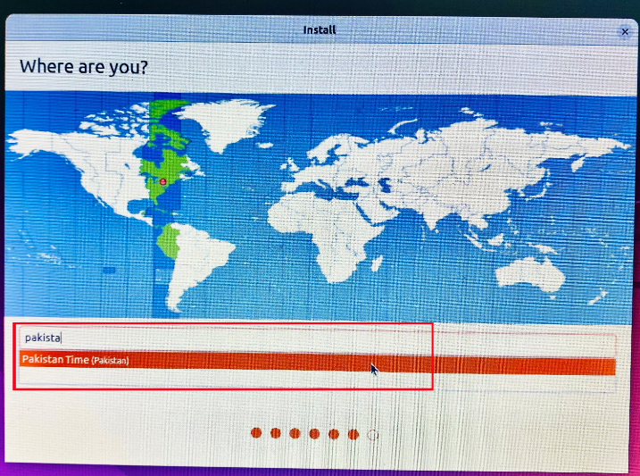

1. ***Fill up the Form As shown in below image:***

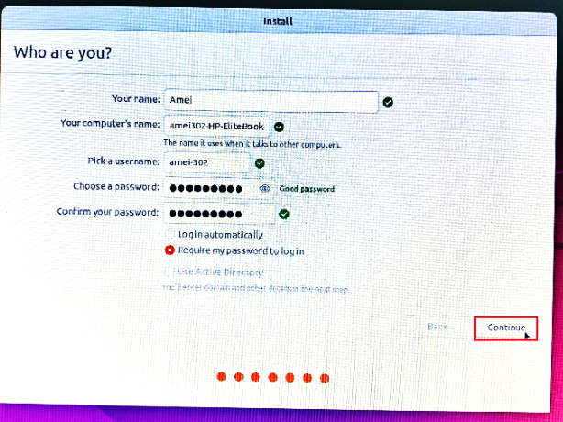

1. 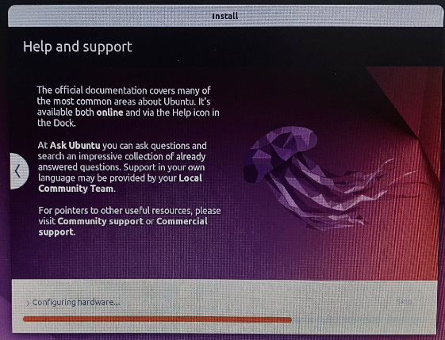***Installation Will be started:***

1. ***Once Installation is finished you will be asked to restart PC hit enter key.***

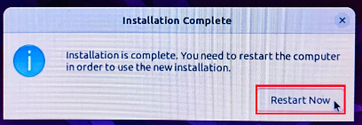

1. 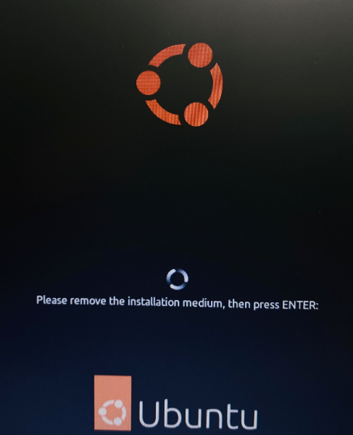***After that you will be asked to remove The Installation Medium, Remove it and press Enter key:***
2. ***Next While The PC Is starting You will be asked to select an operating system Select UBUNTU and press Enter Key****, if it is directly starting Windows Go in the Boot menu by pressing F9 Key and Select UBUNTU Hit enter Key.*

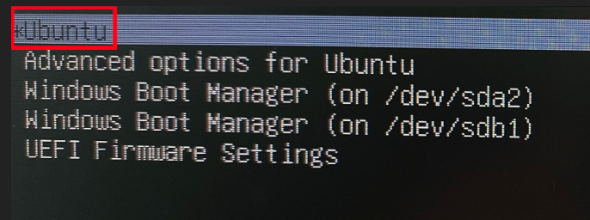

1. ***UBUNTU IS LOADING…..***

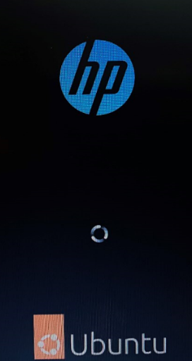

1. ***Enter YOUR PASSWORD:***

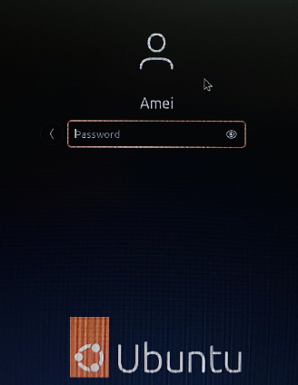

1. ***Next You will be Asked TO ENABLE UBUNTU PRO  
   CLICK ON SKIP FOR NOW AND CLICK ON NEXT AT THE TOP.***

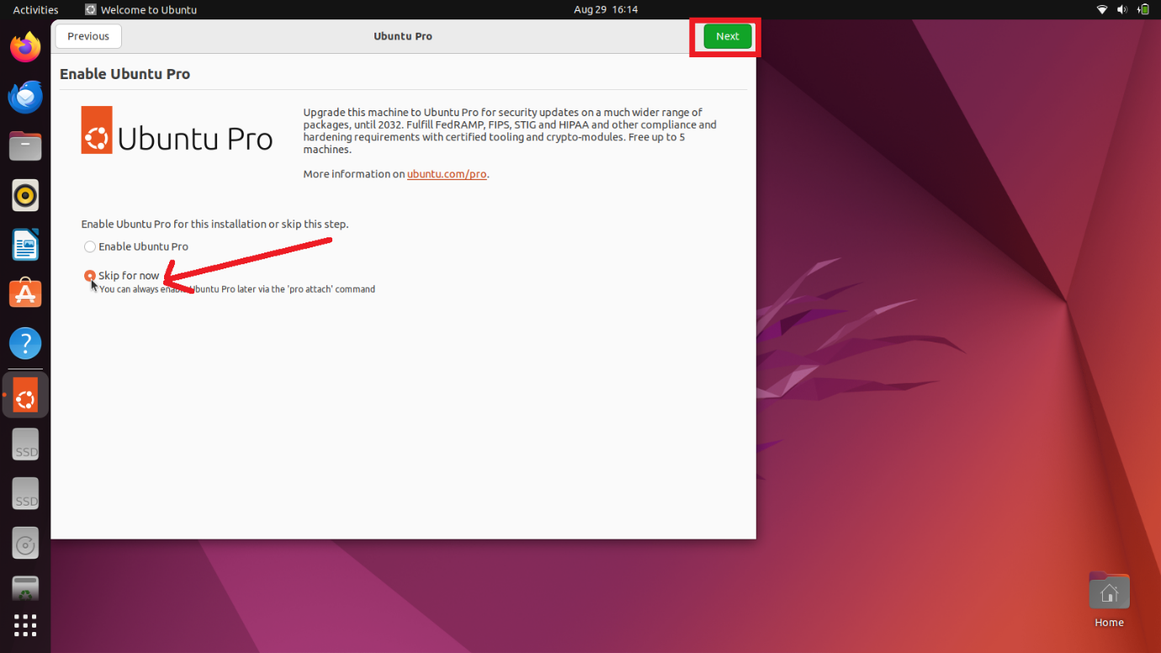

1. ***Next You will be Asked TO: HELP IMPROVE UBUNTU  
   Select NO, DON’T SEND SYSTEM INFO and CLICK ON NEXT in TOP.***

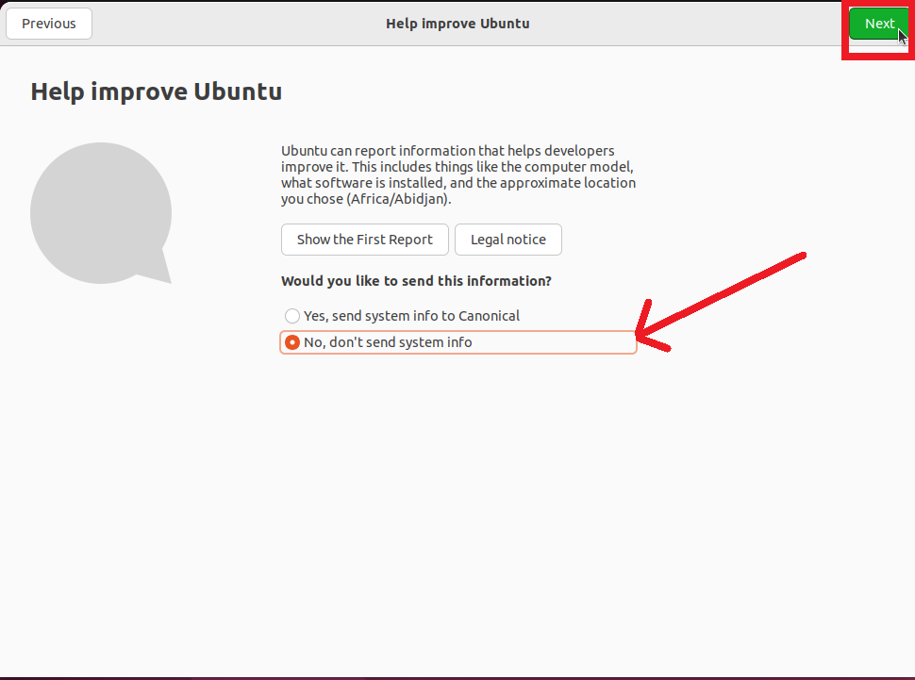

1. ***NEXT, Enable Location Services and CLICK ON NEXT***

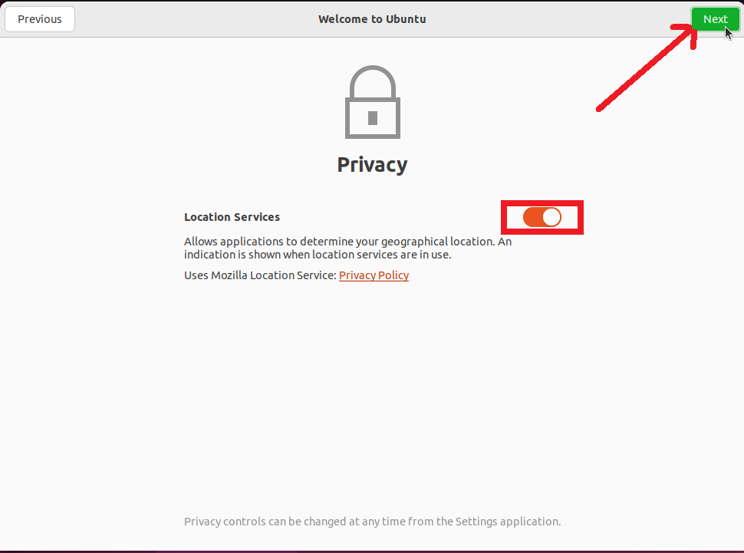

1. ***CONGRATULATIONS! You are done With Installation Process.***